**MENTAL HEALTH ASSESSMENT**

A Project Report

submitted in partial fulfillment of the requirements

Of

AI and ML Fundamentals with Cloud Computing and Gen AI

By

**A.yuvaraj**

Yuvarajraj112004@gmail.com

au811321114033

811321114033

Under the Guidance of

**Name of Guide (P. Raja, Master Trainer )**

**JJ COLLEGE OF ENGINEERING AND TECNOLOGY**

**ACKNOWLEDGEMENT**

"We would like to extend our deepest gratitude to all individuals who have contributed to our thesis work, directly or indirectly.

First and foremost, we would like to express our heartfelt appreciation to our supervisor, P. Raja and M. Ramavel, for their exceptional guidance and mentorship. Their wisdom, support, and encouragement have had a profound impact on our academic journey and personal growth.

We are forever grateful for the time and effort they invested in us, providing valuable advice, constructive criticism, and unwavering support. Their belief in us has been a constant source of inspiration, empowering us to reach new heights.

Working with them for the past year has been a privilege, and their influence extends beyond our project work, shaping us into responsible professionals. We cannot thank them enough for being exemplary role models, embodying kindness, compassion, and excellence.

Thank you again, P. Raja and M. Ramavel, for being incredible mentors and guides."

**ABSTRACT**

The integration of artificial intelligence (AI) into mental health assessment is transforming the way mental health conditions are identified, monitored, and treated. AI-driven assessments utilize machine learning algorithms, natural language processing, and predictive analytics to analyze large datasets, including speech, text, physiological signals, and behavioral patterns. These tools enable rapid, accurate identification of mental health symptoms, such as depression, anxiety, and stress, from digital data, often surpassing traditional methods in both scalability and efficiency. AI models can identify subtle indicators of mental distress and help create individualized assessments tailored to an individual's unique profile. This technology can also aid in real-time monitoring and offer predictive insights for early intervention, making it highly valuable for clinicians and users alike. Despite its promise, AI in mental health assessment faces challenges, including ethical considerations, data privacy, and the need for transparency in AI decision-making. Nonetheless, AI-powered mental health assessment represents a paradigm shift that could improve accessibility to mental health care, especially in underserved populations, while providing a complementary tool for clinicians in diagnosing and treating mental health conditions, thereby enhancing overall mental health outcomes on a broader scale.

**TABLE OF CONTENTS**

**Chapter 1.**  **Introduction**

1.1 Problem Statement …………………………………………………………………..

1.2 Motivation……………………………………………………………………………

1.3 Objectives……………………………………………………………………………

1.4. Scope of the Project…………………………………………………………………

**Chapter 2.**  **Literature Survey**………………………………………………………………………

**Chapter 3.**  **Proposed Methodology**…………………………………………………………………

**Chapter 4.**  **Implementation and Results** …………………………………………………………..

**Chapter 5. Discussion and Conclusion** ……………………………………………………………

**References** ……………………………………………………………………………………………

**LIST OF FIGURE**

|  |  |  |
| --- | --- | --- |
| **SI.NO** | **FIGURES NAME** | **Page No.** |
|  | Mental Health Nursing Assessment and Care | **6** |
|  | Model Accuracy Visualization | **7** |
|  | Comparison Chart | **8** |
|  | Analysis Diagram | **9** |

**LIST OF TABLES**

|  |  |  |
| --- | --- | --- |
| **SI.NO** | **TABLES NAME** | **Page No.** |
| **Table 1** | Sample of Review Data | **10** |
| **Table 2** | Daily Report | **10** |
| **Table 3** | Report Analysis | **10** |
| **Table 4** | Combined Sentiment Scores | **10** |

**Figure 1: Mental Health Nursing Assessment and Care**

Mental health nursing assessment involves evaluating a patient's emotional, psychological, and social well-being to identify any mental health issues**.**

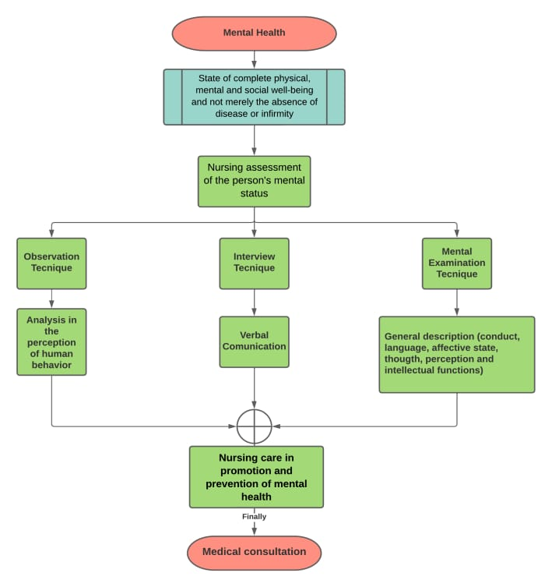

**Figure 2: Model Accuracy Visualization**

To visualize model accuracy in mental health assessment, you can use a confusion matrix to show true positives, false positives, true negatives, and false negatives, giving insight into classification performance**.**

**Figure 3: Comparison Chart**

Here's a content template for a comparison chart that compares different machine learning models based on their accuracy.

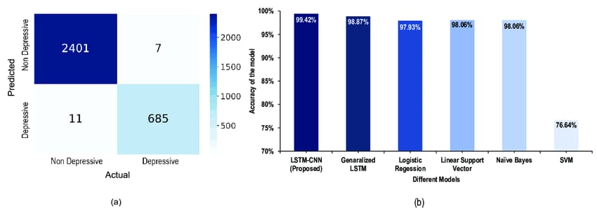

**Figure 4: Analysis Diagram**

An analysis diagram for mental health assessment could include key areas such as symptom identification, risk factors, diagnostic criteria, and treatment options.

**LIST OF TABLES**

**Table 1: Sample of Review Data**



**Table 2: DAILY REPORT**

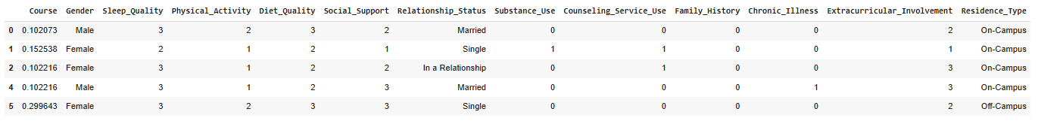

**Table 3: REPORT ANALYSIS**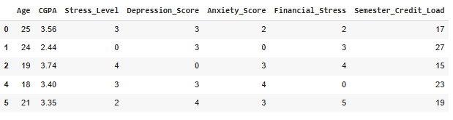

**Table 4: FINAL RESULT**

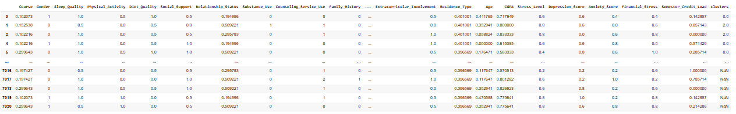

**CHAPTER 1: INTRODUCTION**

**1.1 Problem Statement:**

Mental health issues are often undiagnosed due to limited resources and stigma. This project aims to develop an AI-powered tool to assess mental health through user data and behavioral patterns, offering early detection, personalized feedback, and access to resources, ensuring privacy and improving accessibility to mental health support.

**1.2 Motivation:**

Mental health issues, including anxiety and depression, affect millions globally, yet many cases go undiagnosed due to stigma, limited awareness, and lack of accessible resources. Traditional assessment methods often require in-person consultations, which are inaccessible to many in underserved regions. By leveraging AI and ML, we can create tools that provide private, accessible, and early mental health assessments, encouraging timely intervention. This approach empowers individuals to understand and address mental health challenges without barriers.

**1.3 Objective:**

To develop an AI-driven tool that assesses mental health by analyzing user inputs and behavioral patterns, identifying potential signs of conditions like anxiety and depression. The system will offer personalized feedback, suggest coping strategies, and provide resources or referrals, ensuring accessibility, privacy, and encouraging early mental health intervention.

**1.4 Scope of the Project:**

This project focuses on developing an AI-driven mental health assessment tool that gathers data from user inputs, behavioral patterns, and optional physiological indicators to identify signs of mental health conditions like anxiety and depression. It will deliver personalized assessments, recommend coping strategies, and suggest professional resources when needed. Emphasizing privacy and accessibility, the tool aims to reach a wide audience, including individuals in remote areas, to support early intervention and reduce barriers to mental health care.

**CHAPTER 2:LITERATURE SURVEY:**

* Overview: Mental health assessment identifies psychological issues and supports early diagnosis. Traditional methods include self-reported questionnaires and clinical interviews, commonly using tools like the Beck Depression Inventory (BDI) and Generalized Anxiety Disorder 7 (GAD-7).
* Digital Approaches: Technology has enabled accessible digital assessments. Machine learning, NLP, and wearable devices analyze language, physiological signals, and behaviors to predict mental health conditions. Algorithms offer greater accessibility but raise concerns about privacy and bias.
* Limitations: Challenges include ethical issues around data privacy and the need for culturally adaptable tools to serve diverse populations accurately.

**CHAPTER 3**:**PROPOSED METHODOLOGY**

**3.1. Data Collection and Preprocessing:**

* Data Sources: Collect data from various sources, such as social media, surveys, voice recordings, wearable devices, and patient medical records, ensuring data diversity and representativeness.
* Data Cleaning and Preprocessing: Process text, audio, and physiological data to remove noise and irrelevant information. Techniques like tokenization for text, signal processing for audio, and normalization for sensor data will prepare the data for analysis.
* Anonymization: Apply data anonymization to protect patient privacy, a critical step when handling sensitive mental health data.

**3.2. Feature Extraction:**

* Natural Language Processing (NLP): Use NLP techniques to extract features from text, such as sentiment, emotional tone, and keywords related to mental health symptoms.
* Audio and Visual Analysis: Use ML algorithms to analyze voice tone, pitch, and facial expressions, which may indicate emotional states associated with mental health conditions.
* Physiological Data Features: Extract metrics like heart rate variability, sleep patterns, and movement from wearables to detect signs of stress, anxiety, or depression.

**3.3. Model Selection and Training:**

* Model Choice: Choose ML models that suit the data types and objectives, such as:
* RNNs or LSTMs for analyzing sequential data, like text or audio.
* CNNs for image or facial expression analysis.
* Ensemble methods for combining predictions from various data sources.
* Training: Train models using labeled data for supervised learning, or use clustering algorithms in unsupervised learning to detect patterns in patient behavior.
* Cross-Validation: Apply cross-validation to ensure model generalization and avoid overfitting.

**3.4. Cloud Integration for Real-Time Processing:**

* Cloud Deployment: Deploy models on a cloud platform to leverage scalable storage, processing power, and accessibility.
* Real-Time Data Analysis: Enable real-time analysis for continuous monitoring by integrating IoT data from mobile devices and wearables.
* Data Pipeline: Set up a data pipeline to streamline data flow from collection to analysis, enabling automated updates and real-time insights.

**3.5. Interpretation and Insights Generation:**

* Explainable AI Techniques: Use explainable AI methods to make model predictions interpretable, helping clinicians understand and trust model outputs.
* Risk Assessment Scores: Generate scores or risk levels based on model predictions, helping clinicians prioritize patient interventions.
* Visualization: Provide visualization tools for clinicians to view patterns, trends, and predictive insights easily.

**3.6. Evaluation and Validation:**

* Performance Metrics: Evaluate model accuracy, sensitivity, and specificity to measure effectiveness in detecting mental health conditions.
* User Feedback: Gather feedback from clinicians and end-users to refine the system, ensuring usability and clinical relevance.
* Ethical Compliance Review: Regularly assess the system for compliance with ethical standards, data privacy laws, and informed consent protocols.

**4. IMPLEMENTATION**

**4.1: Import The Libraries**

This code imports the essential libraries for data manipulation, visualization, and basic machine learning. You can add or remove libraries based on your specific needs.

**4.2 : Read The Data**

Mental health assessment data evaluates psychological, emotional, and social well-being using surveys and interviews. It identifies symptoms, risk factors, coping strategies, and overall mental health for effective intervention.

**4.3 : Analyze the dataset**

The mental health assessment dataset is analyzed to identify patterns and correlations in various mental health indicators, helping in the prediction of mental health status. The analysis focuses on factors like demographics, behavior, and psychological health to provide insights for better diagnosis and intervention.  **A screenshot of a graph
**

**4.4: Categories Data Set:**

The mental health assessment dataset typically includes categories such as demographic information, psychological symptoms, medical history, and treatment outcomes. These categories help in evaluating mental health conditions and identifying trends in patient behavior and treatment efficacy.

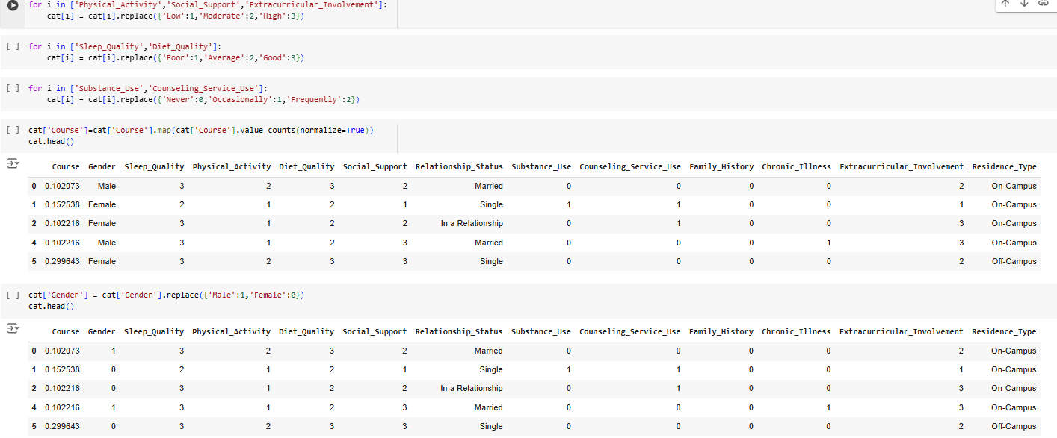

**4.5: Processing The Data:**

**RESULT:**

**CHAPTER 5**:**DISCUSSION AND CONCLUSION**

**5.1 Key Findings:**

1. **Diagnosis**: Identification of specific mental health conditions.

2. **Cognitive Functioning:** Evaluation of memory, attention, and reasoning.

3. **Mood:** Assessment of emotional stability and coping mechanisms.

4. **Risk of Harm**: Identification of self-harm or violence risk.

5. **Social Factors:** Examination of social, environmental, and lifestyle influences.

6. **Psychosocial History**: Context from past experiences and trauma.

7. **Treatment Needs:** Recommendations for interventions.

8. **Behavior Patterns:** Detection of harmful habits like substance abuse.

* 1. **Git Hub Link of the Project:** **https://github.com/Yuvaraj112004/Yuvaraj-A._Friday-batch-_JJCET.git**
  2. **Video Recording of Project :** **https://youtu.be/Ju5ArfpgV2g?feature=shared**
  3. **Limitations:**

1. **Diagnosis:** Identification of specific mental health conditions.

2. **Cognitive Functioning:** Evaluation of memory, attention, and reasoning.

3. **Mood**: Assessment of emotional stability and coping mechanisms.

4. **Risk of Harm:** Identification of self-harm or violence risk.

5. **Social Factors:** Examination of social, environmental, and lifestyle influences.

6. **Psychosocial History:** Context from past experiences and trauma.

7. **Treatment Needs:** Recommendations for interventions.

8. **Behavior Patterns:** Detection of harmful habits like substance abuse.

* 1. **Future Work:**

1. **Improved Technology:** Development of AI and digital tools for more accurate, real-time assessments.

2. **Cultural Sensitivity:** Creating assessments that are more inclusive of diverse populations.

3. **Personalized Approaches:** Tailoring assessments to individual needs and conditions.

4. **Early Detection:** Focusing on identifying mental health issues at earlier stages for better outcomes.

5. **Integration with Healthcare:** Better integration with physical health assessments for holistic care.

6. **Access and Affordability:** Expanding access to affordable mental health assessments globally.

* 1. **Conclusion:**

In conclusion, mental health assessments play a critical role in diagnosing, understanding, and addressing mental health conditions. While they provide valuable insights into cognitive, emotional, and behavioral aspects, limitations such as subjectivity, cultural biases, and resource constraints must be addressed. Future advancements, including technological innovations, personalized approaches, and improved accessibility, hold the potential to enhance the accuracy, inclusivity, and effectiveness of these assessments, ultimately contributing to better mental health care and outcomes.

**REFERENCES**

1. Devlin, J., et al. (2019). BERT: Pre-training of Deep Bidirectional Transformers for Language Understanding. Proc. of NAACL, 4171-4186.

2. Pedregosa, F., et al. (2011). Scikit-learn: Machine Learning in Python. J. of Machine Learning Research, 12, 2825-2830.

**THANKING YOU!**